Case 3-Indus-Bowl-Naga-3000 BCE

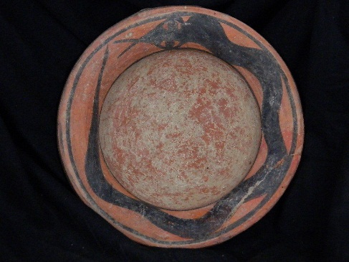 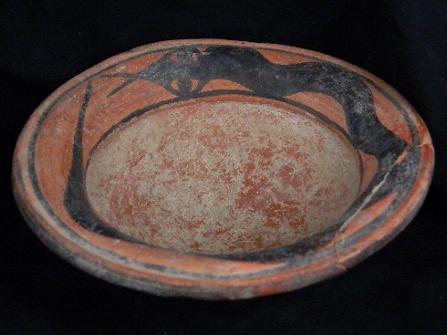 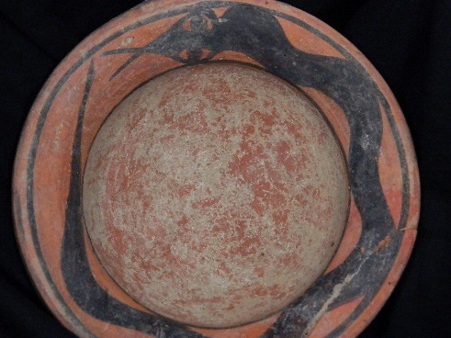

**Formal Label: Indus Valley Bowl with Encircling Naga, 3000 BCE**

**Accession Number:**

**LC Classification:** DS425

**Date or Time Horizon:** 3000 BCE

**Geographical Area:** Indus Valley

**Cultural Affiliation:** Indus Civilization

**Medium:** Terracotta

**Dimensions:   
Weight:**

**Provenance: Ex European Collection, 1970-2016.**

**Condition:** Broken rim portion, glued

**Discussion:** The Sanskrit word *Naga* has its root *nag* the word for “serpent”. In Indian mythology, Nagas are primarily serpent-beings living under the sea. The encircling Naga is an emblem of the amphisbaenic serpent that resurrects its self by shedding its skin periodically. It symbolizes, in Jungian terms, the regeneration of a new trans-personal self from the limited human ego. This image contradicts the Judeo-Christian reading of the Adam and Eve encounter with the serpent in the Garden of Eden where this emergence of the new self is deemed a crime against Yahweh. This comparison of the two serpents and their impacts on the human psyche perfectly characterizes the difference between Eastern and Western views of spiritual enlightenment.

Therefore, this bowl would have been used in a ritual context that contained a libation of water that conferred upon the acolyte the blessings of the amphisbaenic Naga in the unfolding of the trans-personal self. In Hindu mythology this is expressed as the self-sacrifice of the primordial being for the sake of creating the world. In Christianity it is the self-sacrifice of the Christ for the salvation of humanity (Elder 2012: 46).

**References:**

Elder, George R. 2012. *The Snake and the Rope: A Jungian View of Hinduism*. Indianapolis, IN: Dog Ear Publishing, LLC.

# Semeka-Pankratov, Elena. 1979. “A semiotic approach to the polysemy of the symbol Naga in Indian mythology,” *Semiotica* 27(1979)1/3: 227 – 289.